Reexam 2024
Problem 1

- Both players have a strctly dominating strategy in playing $H$ giving us a unique NE in $\left(H,H\right)$Giving utility $(30,30)$both players have a strctly dominant strategy taking us to a EQ in which it is possible to make a pareto imporvement. In this case if poth players play L

- By deviating a player will get 15 in the first round and loose 10 in every round after
Deviation gives a change in total utility
$$Δu=15-10·\frac{δ}{1-δ}$$
It is an eq if there is no incentive to deviate i.e
$$15-10·\frac{δ}{1-δ}≤0$$
$$δ∈[\frac{3}{5},1]$$
$$δ_{low}=\frac{3}{5}$$
By symmertry it is the same for the other player giving us the same lowest $δ$

- Well ive actually used the one step deviation pricipal to show that the strategy profile is a SPNE
Since every SPNE is NE we got that it was also an NE
The one step deviation principal states that if there are no single step in which a player wants to deviate we know that it is a SPNE for a repeating strateg we jus need to check for each state in a cycle since we had a cycle with one step i just showed it for a deviation in that 1 step

In short: there is no one step in which a player wants to deviate when the discountfactor is higher than $δ≥\frac{2}{3}$

- Id prefer to just check it
A player will only deviate in the state where they get 20 not 55
This gives total change in utility
$$10-25·\frac{δ}{1-δ^{2}}+10·\frac{δ^{2}}{1-δ^{2}}≤0$$
$⇕$ Uligheden løses for delta vha. WordMat.
$$δ≤-1 ∨ \left(δ≥\frac{2}{5} ∧ δ≤1\right)$$
Yes it is slightly lower
The player gives up a much bigger gain in the nexp period by deviating meaning that the discount factor needs to be that much lower

Problem 2

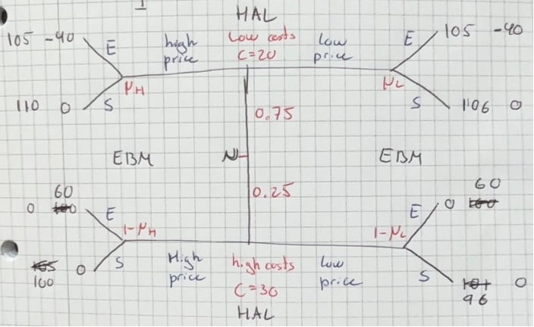

SSHH

$$\frac{3}{4}·105=\frac{315}{4}=78,75$$
$$\frac{3}{4}·-40+\frac{1}{4}·60=-15$$

Problem 3

Problem 4

